Empathy Map

An empathy map helps us understand the needs, thoughts, feelings, and behaviors of end users. For the Metro Ticket Generating System, the primary users are metro passengers who expect a fast, convenient, and reliable ticket booking experience.
By analyzing user expectations and pain points, the project is designed to improve customer satisfaction through automation and digital ticketing.

Objective
The objective of this empathy map is to understand:
- Passenger expectations
- Problems faced during metro ticket booking
- User behavior
- Opportunities for improving the booking experience
This analysis guided the design and development of the Metro Ticket Generating System.

Target User
Primary User: Metro Passenger
Secondary Users:
- Metro Station Manager
- Metro Operations Team
- ServiceNow Administrator

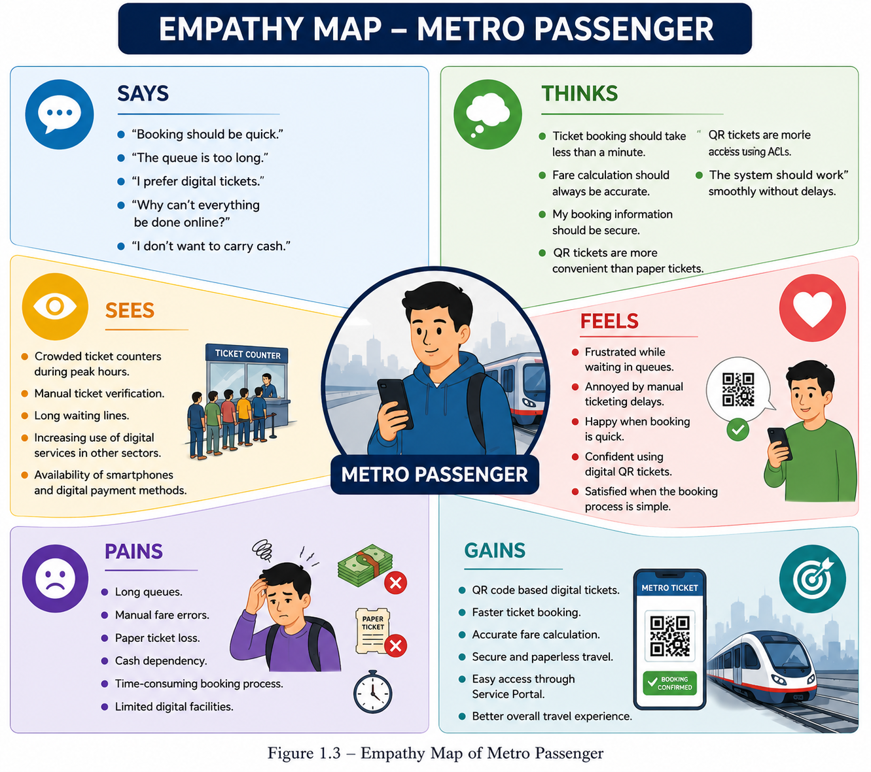

🗣 Says
Passengers often say:
- “The queue is too long.”
- “Booking should be faster.”
- “I prefer digital tickets.”
- “Why can’t everything be done online?”
- “I don’t want to carry cash.”

💭 Thinks
Passengers think:
- Ticket booking should take less than a minute.
- Fare calculation should always be accurate.
- My booking information should be secure.
- QR tickets are more convenient than paper tickets.
- The system should work smoothly without delays.

👀 Sees
Passengers observe:
- Crowded ticket counters during peak hours.
- Manual ticket verification.
- Long waiting lines.
- Increasing use of digital services in other sectors.
- Availability of smartphones and digital payment methods.

❤️ Feels
Passengers feel:
- Frustrated while waiting in queues.
- Annoyed by manual ticketing delays.
- Happy when booking is quick.
- Confident using digital QR tickets.
- Satisfied when the booking process is simple.

🎯 Gains
Passengers gain:
- Faster ticket booking.
- Reduced waiting time.
- Secure digital tickets.
- Accurate fare calculation.
- Easy access through the Service Portal.
- Better travel experience.

😟 Pains
Passengers face:
- Long queues.
- Manual fare errors.
- Paper ticket loss.
- Cash dependency.
- Time-consuming booking process.
- Limited digital facilities.

How the Proposed Solution Addresses User Needs
The Metro Ticket Generating System provides:
- Online ticket booking through ServiceNow.
- Automatic fare calculation.
- QR code-based digital tickets.
- Secure storage of booking records.
- Role-based security.
- User-friendly Service Portal.
- Reduced dependency on manual operations.

